**Looking back at the achievements of BRAMIR**

**Final Conference: The BRAMIR Symposium**

BRAMIR Newsletter #1V – July 2018

Over the past two years, the BRAMIR project team has developed a wide variety of high-quality products to support the beneficial relationships between senior volunteers and migrant communities. On June 15th 2018, the partnership gathered in Schwerin, Germany, and held a symposium in honour of the accomplishments in the BRAMIR project. Partners from Romania, Ireland, Italy, Germany, France, Finland, Cyprus, Austria, and Switzerland presented not only the products of the project to the audience, but also addressed contemporary trends and issues concerning migration and immigration in Europe.

The BRAMIR multi-layered learning framework unites two essential integrational challenges: implementing a bottom-up approach towards migration that starts in local communities and achieves this aim by raising awareness of crucial elements of everyday life on both sides, locals and migrants. For locals, the most important elements of integration are considered the understanding of and compliance to local manners, norms, and customs, as well as acquiring the national language. By banding senior volunteers and migrants together during the BRAMIR project, a symbiotic learning partnership is achieved that brings mutual benefits to both communities.

As the project will be finished soon, the partnership looks back on their achievements. All products of the BRAMIR project are available for free download on the BRAMIR e-learning portal.

**1. Summary Research Report & Needs Analysis.**

The research was conducted in all partner countries and provided insights of national best-practice examples, needs and expectations concerning the BRAMIR approach.

**2. Psychographic Profiling Tools.**

To build long-lasting bounds in the learning partnership between senior volunteers and migrants, a combination of a well-proofed personality test was combined with various national approaches that emphasised on local norms and customs, including the analysis of sinus milieu® groups within migrant communities.

**3. Induction Training Programme.**

The BRAMIR training approach is multi-layered and starts with the immersion of professional trainers into the context and framework of the project. After completing the induction training, professionals are ready to train the senior volunteers.

**4. Train-the-Trainer Curriculum.**

Training seniors to be trainers for their migrant counterpart in the learning partnership builds the heart of the BRAMIR training. In this modular 150 hours blended-learning course, senior volunteers learn a variety of essential skills like intercultural communication, self-management, facilitation and tutoring skills, and also basic ICT-skills. The combination of face-to-face workshops and self-directed learning phases enables trainers and senior volunteers to focus on the most relevant issues and topics, always including the experiences of life of the participants.

**5. E-learning Portal.**

The BRAMIR E-learning portal provides all products and resources that were developed in the course of the project. No matter if using a computer, laptop, or mobile device – the portal is accessible and optimised for all web-enabled devices.

**6. Digital Toolbox of Key Competence Acquisition Resources.**

This resource is directed primarily to adult migrants in order to help developing key civic and social competences essential for integration, though it is also informative for senior volunteers.

**7. BRAMIR Policy Paper.**

The BRAMIR policy paper represents the culmination of the 2-year project as is wraps up the achievements of the partnership and provides suggestions and ideas on how the BRAMIR approach can be implemented across Europe in the future, ensuring an ongoing post-project engagement

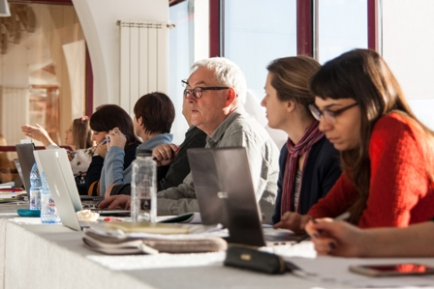

**The BRAMIR Policy Paper**

The final product of the BRAMIR project is the policy paper. This document provides a short overview of the BRAMIR project, its importance in an EU policy context and the outcomes achieved between September 2016 and August 2018. The paper emphasises the BRAMIR approach, which could be considered a positive model of engaging senior volunteers and migrant communities and as such presents the ways in which the BRAMIR model can be replicated in other organisations and communities. Finally, it highlights reasons why the BRAMIR approach should be considered by local and national policy and decision makers in order to respond to contemporary issues of labour market shortages, integration and migration.

The BRAMIR policy paper will serve in the effort of integrating both: the migrant communities in their social and economic everyday life, and the seniors volunteers by enabling them to be be active contributors to the well-being of their communities.

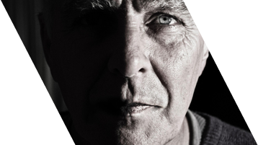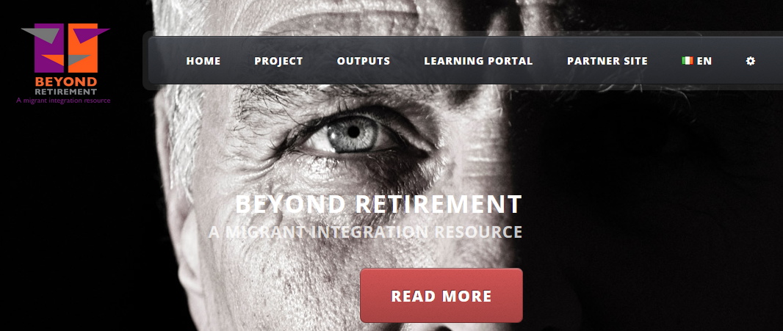

**Get connected with BRAMIR...**

**Website:** [**http://bramir.eu**](http://bramir.eu)

**Facebook:** [**https://facebook.com/bramir.eu**](https://facebook.com/bramir.eu)

* If you are ***trainer in adult education*** and you are interested in developing and/or delivering the BRAMIR training to senior volunteers or
* if you are interested in ***senior voluntary work*** and you would like to participate in the BRAMIR training activities

then please contact the partner in your home country or the project coordinator   
for further information.

The BRAMIR project has developed and implemented a multi-layered ***learning framework designed for seniors*** and older workers approaching retirement to enable them to be redeployed as ***volunteers*** to support the development of key ***civic and social competences*** within the established and growing ***migrant communities.***

Therefore, the BRAMIR project has developed an innovative approach based on ***psychographic profiling*** using criteria including education, social and cultural values, work experience, interests, hobbies and lifestyle; instead of focussing solely on ethnicity or country of origin as the determining factors for social integration.

BRAMIR projects addresses ***adult education trainers and providers, volunteer managers, migrant support workers, senior volunteers and migrants.***

If you are a member of one of these groups, why not contact us!

The BRAMIR consortium comprises 9 partners and 1 associated partner. All together 8 Member States are represented: Germany, Ireland (2), Romania, Cyprus, Austria, Italy, France, Finland and an associate partner from Switzerland.

**BRAMIR is...**

**BRAMIR at a glance...**

BRAMIR Newsletter #1V – July 2018