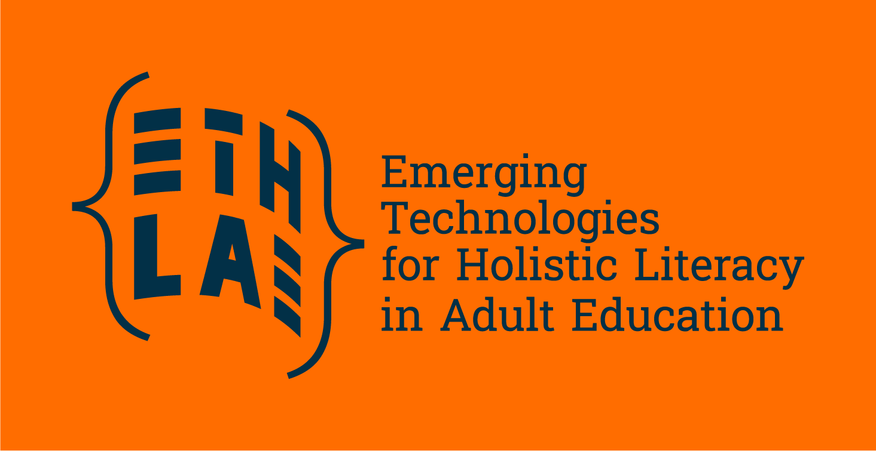
Making technology work for adult learners: our 6 key research findings
While emerging technologies promise to support adult learning with better access and potential personalisation, significant challenges remain. Across countries and institutions, the integration of digital tools remains uneven, not due to lack of ambition, but because of insufficient resources and training and limited policy support.
From educators struggling without adequate training to organisations lacking access to resources and software licenses, the ETHLAE research shows once more why digital inclusion requires far more than simply providing devices or internet access. In the last months, the ETHLAE consortium, coordinated by EAEA, conducted field and desk research on the implementation of emerging technologies in education, with a particular focus on adult learning and literacy programmes. The research, coordinated by Algebra University, covered Austria, Croatia, Finland, Romania, Switzerland, UK and the EU level, and counted with the participation of almost 50 practitioners, educators, digital experts and learners.
Check the 6 key findings of our desk and field research.

Key findings of our research

Emerging technologies hold promise, but are unevenly integrated
Technologies like AI, learning platforms, and data-driven tools can enhance access and personalisation in adult learning. However, integration is inconsistent across countries and institutions, often hindered by poor infrastructure, lack of training, fragmented policies, and short-term funding.
“We have centres experimenting with AI and adaptive learning, but others can’t even guarantee stable Wi-Fi.”

Digital inclusion is about more than access
Providing devices is not enough. Digital exclusion is linked to confidence, motivation, trust, and support structures. Adults from vulnerable groups or in vulnerable contexts face multiple intersecting barriers: digital, social, and emotional.
“I don’t want to click on something and lose money or send the wrong document. Who can help me if I get it wrong?”

An holistic approach to literacy is critical
Digital skills are ever more important, but learning is most effective when embedded in real-life. Learning digital skills should be done in a contextualised way, and in an emotionally safe environment.
“Digital tools can’t fix a lack of trust,” one stakeholder reflected. “What learners need first is a safe space - then they can start experimenting, clicking, making mistakes.”

Educators need training and support
Many educators feel unprepared to use emerging technologies meaningfully and in an inclusive way. There’s a strong need for capacity-building in digital pedagogy, especially for working with vulnerable groups.
“We don’t have enough pedagogical resources,” one educator said. “We’re good at improvising, but that’s not a sustainable strategy.”

Policy and practice must align

While national and EU policies emphasise digital transformation, implementation often lacks systemic support. Long-term impact depends on sustainable policies, cross- sector collaboration, and ethical use of emerging technologies.

“We saw a surge in digital adoption,” one participant noted, “but much of it was driven by emergency needs, not by long-term planning or systemic change.”

A Pedagogical and ethical lens is essential

Emerging technologies should be treated not as ends in themselves but as tools for empowerment and inclusion. Ethical, context-aware use of tech is needed to promote
social cohesion and digital citizenship.

“If we only teach them how to use a platform, we’re missing the point. We need to build trust, motivation and a sense of belonging. That’s where learning really starts.”

Emerging technologies can support inclusion, but only when applied ethically and based on the specific needs and context of learners. Adult learners need time and support to build trust before they can effectively engage with digital tools, and educators require training, time, and recognition for their evolving roles. While the role of educators and organisations is crucial, action at the policy level is needed: sustainable change in adult learning is only possible when policy and practice are properly aligned.

Read the full research document, the country reports or the adult learners stories at: https://eaea.org/project/ethlae/

